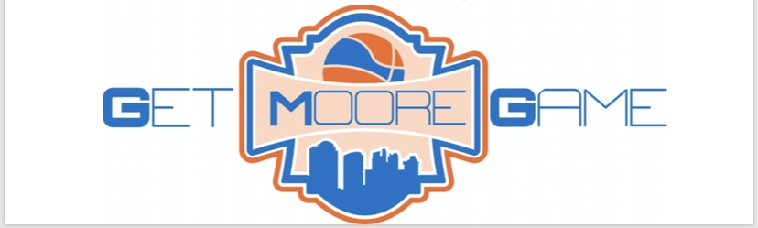

Contract and Agreement

To conduct my business effectively and efficiently the following terms and conditions apply:

1. **GENERAL TERMS**

Client is acknowledging that he/she is agreeing for the services provided by Get Moore Game. Training programming shall vary as well as their time depending on the needs of the athlete.

1. **ATTACHMENT**

Client has gone through their one-time full body assessment before purchasing any training package provided by Get Moore Game. Training programming shall vary as well as their time depending on the needs of the athlete.

1. **TRAINING PACKAGE/PAYMENT**

Training packages/programs include the demand of various activities. These activities include: muscle strength, speed and agility, movement, weight training, free weights, and any other training activities, techniques, and/or exercises.

A payment of _____________________________________ will be paid monthly or bi-weekly on the 1st and/or 15th via check or credit card made out to Get Moore Game or Zephaniah Moore. This is a monthly payment to receive your designated training package. Unless notified more than 24 hours in advance, there will be no refund for an athlete being absent for a workout. Refund policy is only for catastrophic illness, major injury, or otherwise determined by Zephaniah Moore.

This agreement shall be signed on behalf of Get Moore Game by _________________________   
  
and the client __________________________________________________________________.

Payment Method:  ***CHECK / CREDIT CARD***

*Any Client under the age of 18 must have a parent or legal guardian sign this agreement.*

(Parents Signature, Please Print) (DATE)

(Athletes Signature, Please Print) (DATE)